
per person in HK$ / 每位收費以港幣計算
Hotel Name  酒店名稱 | B’fast  早餐 | Validity  有效日期 | Adult成人 |  |  | Child小童
Hotel Name  酒店名稱 | B’fast  早餐 | Validity  有效日期 | Twin  雙人房 | Single  單人房 | Extra Bed  加床 | Twin  雙人房 | Extra Bed  加床 | No Bed  不佔床
Naha 那霸市區
Okinawa Harbor View (5＊)  www.crowneplaza-harborview.jp  從那霸機場搭車約10分鐘 | ✗ | 23 Sep – 25 Oct | 4,550 | 5,750 | 3,850 | 3,950 | 3,250 | 2,150
 | ✗ | 23 Sep – 25 Oct | Fri - SAT & Pre-Holiday Eve. stay surcharge星期五至六及公眾假期前夕入住附加費:  Single $120 / Twin $200 / Triple 280 per room per night 每房每晚
Okinawa Miyako Hotel (4＊)  www.miyakohotels.ne.jp/okinawa  從那霸機場搭車約20分鐘 | ✗ | 23 – 30 Sep | 3,890 | 4,250 | 3,750 | 3,350 | 3,150 | 2,150
 | ✗ | 01 – 25 Oct | 3,950 | 4,290 | 3,750 | 3,350 | 3,190 | 2,150
Okinawa Pacific Hotel (3＊)  www.pacifichotel.jp  從那霸機場搭車約15分鐘 | ✗ | 23 Sep – 25 Oct | 3,390 | 3,890 | 3,190 | 2,790 | 2,590 | 2,150
Station Hotel Makishi (3＊)  www.hotel-makishi.com  從單軌列車牧志站步行1分鐘 | ✓ | 23 Sep – 25 Oct | 3,550 | 3,650 | 3,490 | 2,950 | 2,950 | N/A
 | ✓ | 23 Sep – 25 Oct | Black out 不適用於: 12 – 13 Oct
Okinawa Washington Hotel (3＊)  www.okinawa-wh.com  從那霸機場搭車約15分鐘 | ✗ | 23 Sep – 25 Oct | 3,450 | 3,750 | N/A | 2,890 | N/A | N/A
Beach 海灘區
Kariyushi Beach Resort Onna (4＊)  www.kariyushi.co.jp/english/beach/index.htm  從那霸機場往北搭車約90分鐘 | ✓ | 23 Sep – 25 Oct | 4,490 | 5,750 | 4,190 | 3,950 | 3,650 | N/A
Marriott Okinawa Resort & Spa (5＊)  www.okinawa-marriott.com  從那霸機場搭車約90分鐘 | ✓ | 23 – 30 Sep | 6,650 | 8,190 | 4,950 | 6,090 | 4,390 | N/A
 | ✓ | 01 – 25 Oct | 5,850 | 7,450 | 4,450 | 5,290 | 3,850 | N/A
Okinawa Zanpamisaki Royal (5＊)  www.daiwaresort.co.jp/okinawa  從那霸機場搭車約90分鐘 | ✓ | 23 Sep – 12 Oct | 4,650 | 5,590 | 4,690 | 4,050 | 4,090 | N/A
 | ✓ | 13 – 25 Oct | 4,150 | 4,990 | 4,050 | 3,550 | 3,490 | N/A
 | ✓ | 13 – 25 Oct | SAT & Pre-Holiday Eve. stay surcharge星期六及公眾假期前夕入住附加費:  Single $100 / Twin $170 / Triple $250 per room per night 每房每晚
Rizzan Sea Park Hotel (5＊)  www.rizzan.co.jp  從那霸機場搭車約60分鐘 | ✓ | 23 Sep – 25 Oct | 4,490 | 5,750 | 4,190 | 3,950 | 3,650 | N/A
＊酒店繁多未能盡錄，如有需要請向本公司職員查詢＊
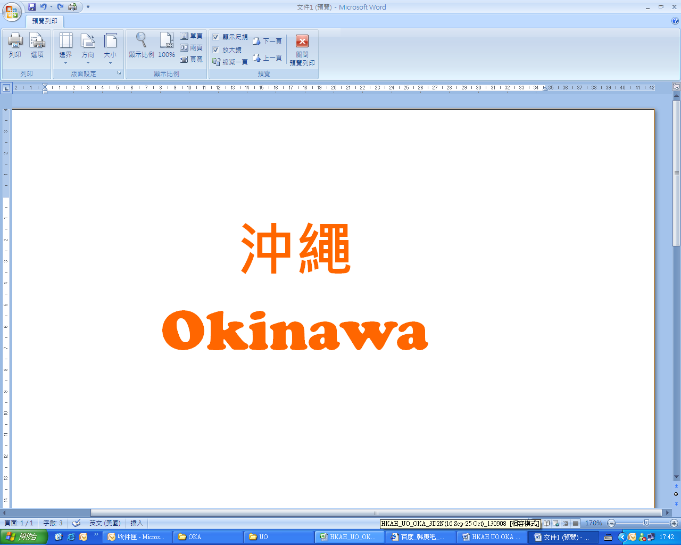
3 Days 2 Nights Package
3日2夜自由行
23/09/2008 – 25/10/2008
Flight Schedule 航班時間表
HK香港 →Okinawa沖繩 | UO602 | 12:25 / 16:00 | Sun & Thu
HK香港 →Okinawa沖繩 | UO602 | 16:35 / 20:00 | Tue – Wed Fri – Sat
HK香港 →Okinawa沖繩 | UO602 | 16:40 / 20:00 | Mon
Okinawa沖繩→ HK香港 | UO603 | 17:00 / 18:25 | Sun & Thu
Okinawa沖繩→ HK香港 | UO603 | 21:00 / 22:25 | Tue – Wed  Fri – Sat
Okinawa沖繩→ HK香港 | UO603 | 21:00 / 23:00 | Mon

Extension Night延長住宿 (per room per night每房每晚HK$ )
Hotel Name  酒店名稱 | B’fast  早餐 | Validity  有效日期 | Twin  雙人房 | Single  單人房 | Triple  三人房
Okinawa Harbor View | ✗ | 23 Sep – 25 Oct | 1,940 | 1,630 | 2,520
Okinawa Miyako Hotel | ✗ | 23 – 30 Sep | 1,300 | 870 | 1,820
Okinawa Miyako Hotel | ✗ | 01 – 25 Oct | 1,340 | 890 | 1,880
Okinawa Pacific Hotel | ✗ | 23 Sep – 25 Oct | 790 | 690 | 1,030
Station Hotel Makishi | ✓ | 23 Sep – 25 Oct | 940 | 570 | 1,340
Okinawa Washington Hotel | ✗ | 23 Sep – 25 Oct | 870 | 620 | N/A
Kariyushi Beach Resort Onna | ✓ | 23 Sep – 25 Oct | 1,910 | 1,610 | 2,670
Marriott Okinawa Resort & Spa | ✓ | 23 – 30 Sep | 4,060 | 2,860 | 5,200
Marriott Okinawa Resort & Spa | ✓ | 01 – 25 Oct | 3,270 | 2,480 | 4,140
Okinawa Zanpamisaki Royal | ✓ | 23 Sep – 12 Oct | 2,030 | 1,540 | 3,010
Okinawa Zanpamisaki Royal | ✓ | 13 – 25 Oct | 1,540 | 1,240 | 2,220
Rizzan Sea Park Hotel | ✓ | 23 Sep – 25 Oct | 1,910 | 1,610 | 2,670
Hotel Surcharge $$ 酒店附加費: Please refer to the Package $$ Table 請參照套票價錢列表 (P.1)
Air fare surcharge 機票附加費 per person in HK$ / 每位收費以港幣計算
Departure Dates 出發日期 | Booking Class訂位編號 | Ticket Validity機票有效期 | Adult成人 | Child小童
23 – 30 Sep  05 – 25 Oct | V (GV2) | 2 – 7 Days | None
23 – 30 Sep  05 – 25 Oct | K (GV2) | 2 – 7 Days | 100 |  | 90
23 – 30 Sep  05 – 25 Oct | H (GV1) | 2 – 7 Days | 500 |  | 390
01 – 04 Oct | V (GV2) | 2 – 7 Days | 300 |  | 230
01 – 04 Oct | K (GV2) | 2 – 7 Days | 400 |  | 310

Package Inclusion: | 套票包括:
- Roundtrip economy class air ticket HKG-OKA-HKG by UO  - 2 nights accommodation with breakfast (Except Specific Hotels)  - Travel Insurance (Coverage of personal accident up to HK$100,000)  - 0.3% TIC Levy | - 香港快運航空來回香港及沖繩經濟客位機票乙張  - 2晚酒店住宿含早餐 (“x” 指定酒店除外)  - 旅遊保險(人身意外最高賠償HK$100,000)  - 0.3%旅遊業議會印花稅
Terms & Conditions: | 條款及細則:
- Minimum 2 Adults must be travel together on the same flight throughout the journey.  - Booking must be reserved under the SAME record locator (PNR) for all passengers.  - Flights and room confirmation are subject to availability.  - Package is non-endorsable, non-reroutable and non-refundable.  - Prices quoted are on per person basis and subject to change without prior notice.  - Package Prices inclusive of Hong Kong airport security charge (“Q” charge).  - Departure taxes, airlines insurance surcharge, airlines fuel surcharge and travel agent service fee are not included.  - Reservation must be made at least 3 working days prior to departure.  - For reservation made within 7 working days prior to departure, a non-refundable full payment is required.  - Package are based on Electronic Ticket (E-ticket) only. | - 旅程必須至少兩位成人同時出發及回程.  - 所有同行客人必須于同一PNR內訂位.  - 所有預訂須視乎酒店及機位情況方能確定。  - 旅遊套餐在任何情況下都不能更改，轉讓或退還款項。  - 費用均以每人計算，費用如有調整，恕不另行通知。  - 費用已包括香港機場保安稅。  - 費用不包括各地機場離境稅，保險附加費，燃油附加費及旅行社服務費。  - 所有訂位手續須於出發前不少於三個工作天內辦理。  - 凡於出發前7個工作天內辦理預訂手續，須繳付所有款項。  已付之費用概不退還。  - 旅遊套餐只適用於電子機票。

