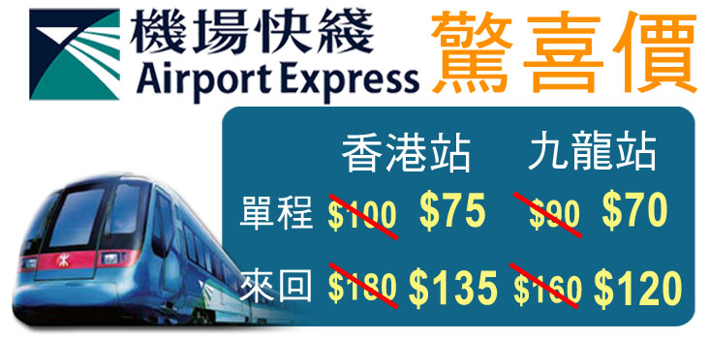
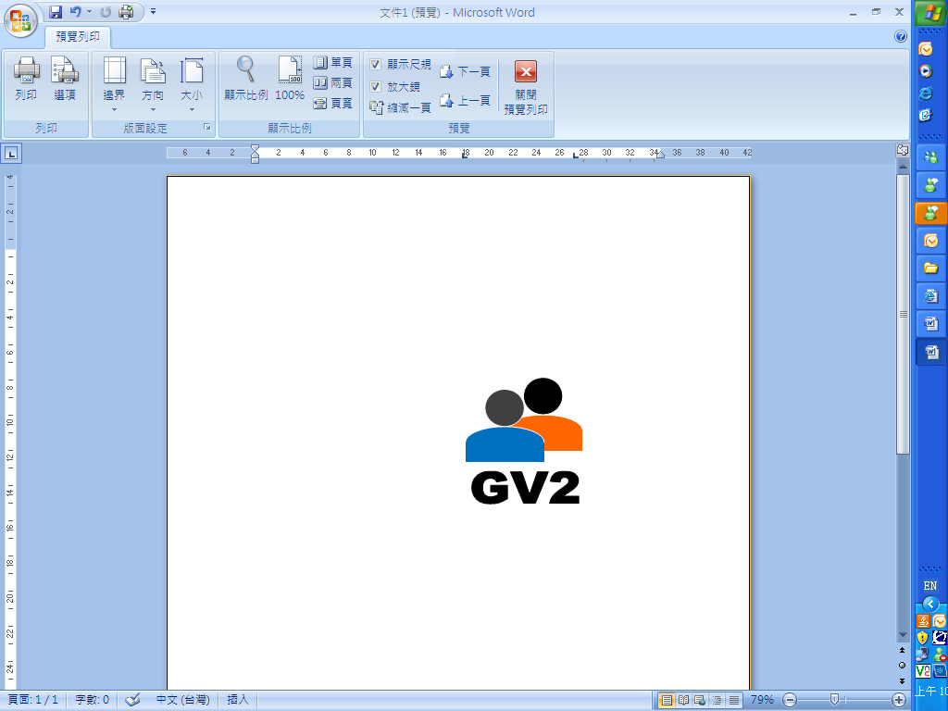
最少2位成人同行
Min. 2 Adults
must be travel together
Bangkok 曼谷
3 Days 2 Nights Package
3日2夜自由行
26/10/2008 – 28/03/2009
HK$ 港幣價目
Hotel Name  酒店名稱 | Room  Type  房間類別 | Validity  有效日期 | Adult成人 |  |  |  | Child小童 |  |  | Extension Night延長住宿  (per room/night 每房每晚)
Hotel Name  酒店名稱 | Room  Type  房間類別 | Validity  有效日期 | Twin  雙人房 |  | Single  單人房 | Extra Bed  加床 | Twin  雙人房 | Extra Bed  加床 | No Bed  不佔床 | Twin  雙人房 | Single  單人房 | Triple  三人房
Siam Area
Ibis Siam (3＊)  www.ibissiam.com | Standard | 26 Oct 08 - 28 Mar 09 | 1,859 |  | 2,259 | N/A | 1,599 | N/A | 1,259 | 490 | 470 | N/A
Pullman Bangkok  King Power (5＊)  www.pullmanbangkokkingpower.com | Superior | 26 Oct 08 - 28 Mar 09 | 2,299 |  | 3,099 | 2,199 | 2,059 | 1,959 | 1,259 | 920 | 900 | 1,260
Courtyard by Marriott (5＊)  **Asian Market only**  www.marriott.com | Deluxe | 26 Oct 08 - 28 Mar 09 | 2,399 |  | 3,299 | N/A | 2,159 | N/A | 1,259 | 1,020 | 1,000 | N/A
Novotel Siam Square (4＊)  www.novotelbkk.com | Superior | 26 Oct 08 - 28 Mar 09 | 2,459 |  | 3,399 | 2,299 | 2,159 | 2,059 | 1,259 | 1,060 | 1,040 | 1,450
Novotel Siam Square (4＊)  www.novotelbkk.com | Superior | 26 Oct 08 - 28 Mar 09 | Compulsory Gala Dinner on 31 Dec 08 $800 per person
Swissotel Nai Lert Park (4＊)  **Worldwide Market except Japanese**  www.swissotel.com | Swiss  Classic | 26 Oct 08 - 28 Mar 09 | 2,559 |  | 3,459 | 2,299 | 2,299 | 2,059 | 1,259 | 1,140 | 1,070 | 1,550
Centara Grand & BCC  at CentralWorld (5＊)  www.centarahotelsresorts.com/cgcw | Superior  World | 26 Oct 08 - 28 Mar 09 | 2,799 |  | 4,059 | N/A | 2,559 | N/A | 1,259 | 1,410 | 1,360 | N/A
Sukhumvit Area
Le Fenix Sukhumvit (4＊)  ** Asia Market except Janpanes & Korean**  www.lefenix-sukhumvit.com | Standard | 26 Oct 08 - 15 Dec 08 |  | 1,999 | 2,499 | N/A | 1,699 | N/A | 1,259 | 610 | 590 | N/A
 | Standard | 16 Dec 08 - 31 Jan 09 |  | 2,059 | 2,599 | N/A | 1,759 | N/A | 1,259 | 650 | 630 | N/A
 | Standard | 01 Feb 09 - 28 Mar 09 |  | 2,099 | 2,699 | N/A | 1,859 | N/A | 1,259 | 710 | 690 | N/A
S15 Sukhumvit (4＊)  www.s15hotel.com | S15 Deluxe | 26 Oct 08 - 28 Mar 09 |  | 2,259 | 2,999 | N/A | 1,999 | N/A | 1,259 | 850 | 830 | N/A
Grand Millennium Sukhumvit (5＊)  **Valid for ASIAN Market only **  www.millenniumhotels.com | Deluxe | 26 Oct 08 - 28 Mar 09 |  | 2,359 | 3,199 | 2,259 | 2,059 | 1,999 | 1,259 | 1,320 | 1,300 | 1,680
 | Deluxe |  |  | Extension Night: Mon - Thu stay surcharge延長住宿: 星期一至四入住附加費:  $110 per room per night 每房每晚
Grand Sukhummvit by Sofitel (5＊)  www.sofitel.com | Silver | 26 Oct 08 - 28 Mar 09 |  | 2,459 | 3,399 | 2,199 | 2,199 | 1,899 | 1,259 | 1,070 | 1,050 | 1,390
＊酒店繁多未能盡錄，如有需要請向本公司職員查詢＊
Flight Schedule 航班時間表 (for reference only 只供參考)
HK香港 → Bangkok 曼谷 | UO 781 | 12:15 / 13:50 | Daily
HK香港 → Bangkok 曼谷 | UO 727 | 16:40 / 18:15 | Tue – Sat
Bangkok 曼谷→ HK香港 | UO 782 | 14:45 / 19:00 | Daily
Bangkok 曼谷→ HK香港 | UO 728 | 19:20 / 23:05 | Tue – Sat

Optional airport transfer自選機場接送
私家車來回機場及酒店每程HK$270 (最多可載8人)
Mini Van between Airport & Hotel HK$270 per Van per way (Max. 8 pax)

Air fare surcharge details 機票附加費詳情 per person in HK$ / 每位收費以港幣計算
Departure Dates 出發日期 | Booking Class  訂位編號 | Ticket Validity  機票有效期 | Adult成人 | Child小童
26 Oct 08 – 19 Dec 08  28 Dec 08 – 21 Jan 09  30 Jan 09 – 28 Mar 09 | V (GV2) | 2 – 7 Days | None
26 Oct 08 – 15 Dec 08 | N (GV2) | 2 – 7 Days | 100 | 80
26 Oct 08 – 28 Mar 09 | M (GV1) | 2 – 7 Days | 350 | 270
26 Oct 08 – 28 Mar 09 | L (GV1) | 2 – 14 Days | 760 | 580
26 Oct 08 – 28 Mar 09 | K (GV1) | 2 – 21 Days | 1,180 | 890
26 Oct 08 – 28 Mar 09 | H (GV1) | 2 – 30 Days | 1,480 | 1,120

Package Inclusion: | 套票包括:
- Roundtrip economy class air ticket HKG-BKK-HKG by UO  - 2 nights accommodation with breakfast (Except Specific Hotels)  - Travel Insurance (Coverage of personal accident up to HK$100,000)  - 0.3% TIC Levy | - 香港快運航空來回香港及曼谷經濟客位機票乙張  - 2晚酒店住宿包早餐 (指定酒店除外)  - 旅遊保險(人身意外最高賠償HK$100,000)  - 0.3%旅遊業議會印花稅
Terms & Conditions: | 條款及細則:
- Minimum 2 Adults must be travel together on the same flight throughout the journey.  - Booking must be reserved under the SAME record locator (PNR) for all passengers.  - Flights and room confirmation are subject to availability.  - Package is non-endorsable, non-reroutable and non-refundable.  - Prices quoted are on per person basis and subject to change without prior notice.  - Package Prices inclusive of Hong Kong airport security charge (“Q” charge).  - Departure taxes, airlines insurance surcharge, airlines fuel surcharge and travel agent service fee are not included.  - Reservation must be made at least 3 working days prior to departure.  - For reservation made within 7 working days prior to departure, a non-refundable full payment is required.  - Package are based on Electronic Ticket (E-ticket) only. | - 旅程必須至少兩位成人同時出發及回程.  - 所有同行客人必須于同一PNR內訂位.  - 所有預訂須視乎酒店及機位情況方能確定。  - 旅遊套餐在任何情況下都不能更改，轉讓或退還款項。  - 費用均以每人計算，費用如有調整，恕不另行通知。  - 費用已包括香港機場保安稅。  - 費用不包括各地機場離境稅，保險附加費，燃油附加費及旅行社服務費。  - 所有訂位手續須於出發前不少於三個工作天內辦理。  - 凡於出發前7個工作天內辦理預訂手續，須繳付所有款項。  已付之費用概不退還。  - 旅遊套餐只適用於電子機票。

